Module 8. Generics and Collections

Generics

Points to Remember

• It is possible to define or declare generic methods in an interface or a class even if the class or the interface itself is not generic.

• A generic class used without type arguments is known as a raw type. Of course, raw types are not type safe. Java supports raw types so that it is possible to use the generic type in code that is older than Java 5 (note that generics were introduced in Java 5).
The compiler generates a warning when you use raw types in your code. You may use @SuppressWarnings({ "unchecked" }) to suppress the warning associated with raw types.

• List<?> is a supertype of any List type, which means you can pass List<Integer>, or List<String>, or even List<Object> where List<?> is expected.

• Implementation of generics is static in nature, which means that the Java compiler interprets the generics specified in the source code and replaces the generic code with concrete types.
This is referred to as type erasure. After compilation, the code looks similar to what a developer would have written with concrete types.

• There are many limitations of generic types due to type erasure. A few important ones are as follows:

You cannot instantiate a generic type using new operator. For example, assuming mem is a field, the following statement will result in a compiler error:
T mem = new T(); // wrong usage - compiler error

You cannot instantiate an array of a generic type. For example, assuming mem is a field, the following statement will result in a compiler error:
T[] amem = new T[100]; // wrong usage - compiler error

You can declare non-static fields of type T, but not of static fields of type T. For example,
class X<T> {
T instanceMem; // okay
static T statMem; // wrong usage - compiler error
}

It is not possible to have generic exception classes; as a result, the following will not compile:

class GenericException<T> extends Throwable { } // wrong usage - compiler error

You cannot instantiate a generic type with primitive types—in other words, List<int> cannot be instantiated. However, you can use boxed primitive types.

The meaning of "extends" and "super" changes in the context of generics. For instance, when you say <? extends X>, you refer to all types that extend X and the type X itself.

The Collections Framework

Basic Components of the Collections Framework

The Java collections framework has three main components:

• Abstract classes and interfaces: The collections framework has many abstract classes and interfaces providing general functionality. By learning them, you’ll know the offered functionality in terms of public methods.

• Concrete classes: These are the actual instances of containers that you’ll be using in the programs.

• Algorithms: The java.util.Collections implements commonly require functionality like sorting, searching, etc. These methods are generic: you can use these methods on different Containers.

Abstract Classes and Interfaces

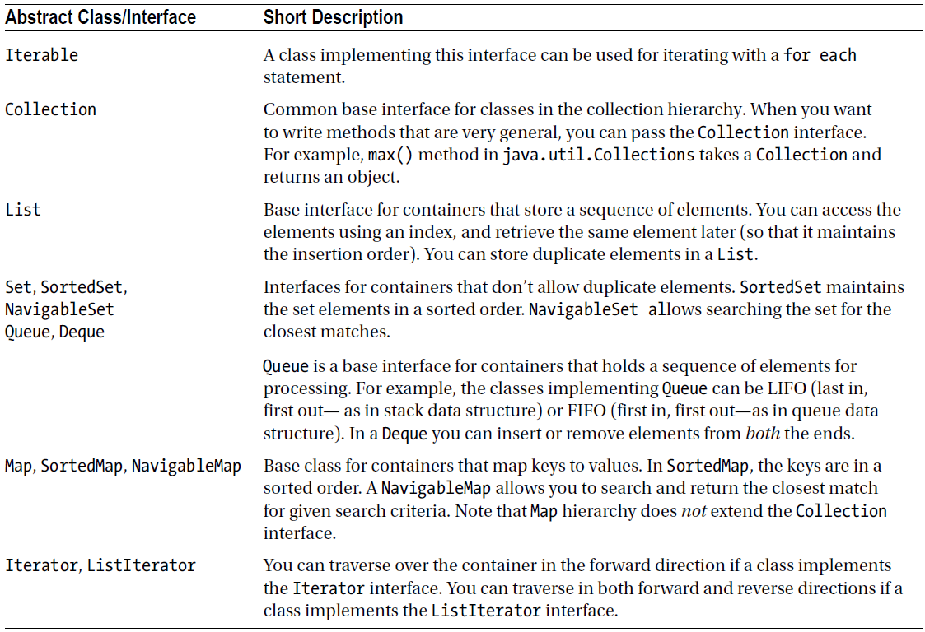

Table. Important Abstract Classes and Interfaces in the Collections Framework

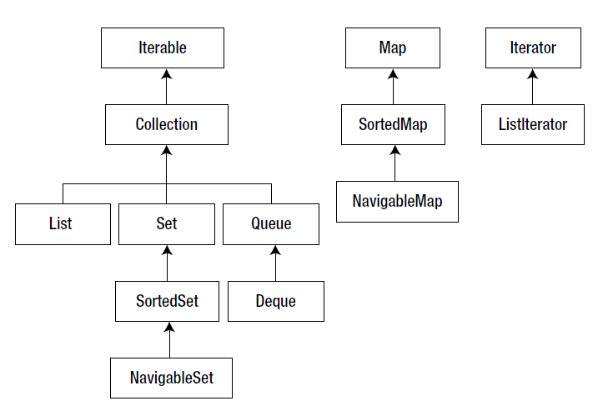

Figure. Important high-level java.util interfaces and their inheritance relationships

The Collection Interface

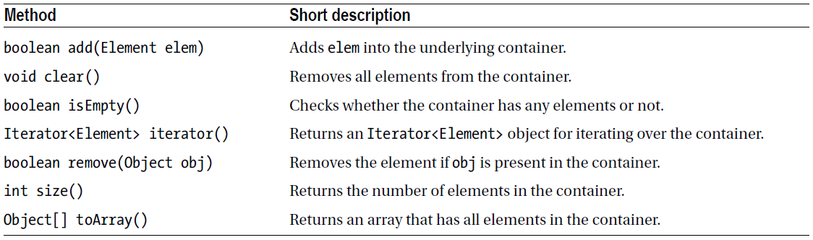

Table. Important Methods in the Collection Interface

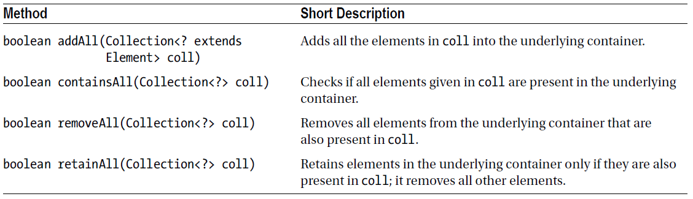

Table. Methods in the Collection Interface That Apply to Multiple Elements

Concrete Classes

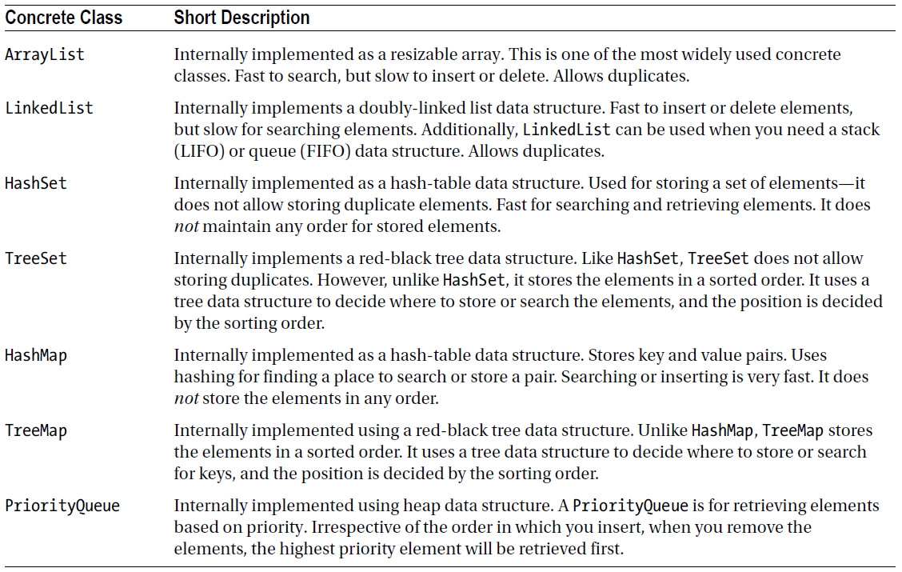

Table. Important Concrete Classes in Collection Framework

The Iterator Interface

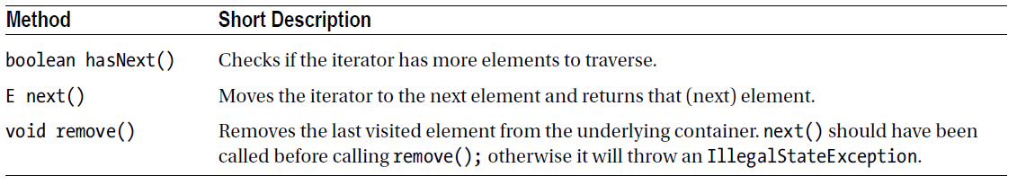

Table. Methods in the Iterator Interface

The ListIterator Interface

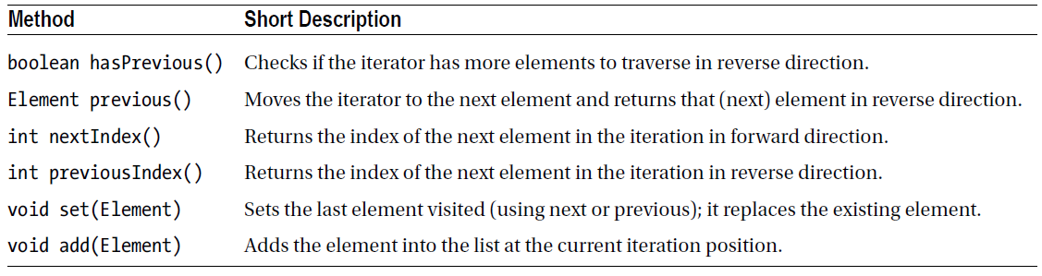

Table. Methods in the ListIterator Interface (in Addition to Iterator Methods)

The Queue Interface

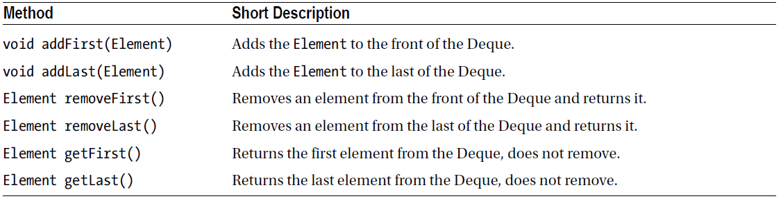

Table. Commonly Used Methods in the Queue Interface

The Deque Interface

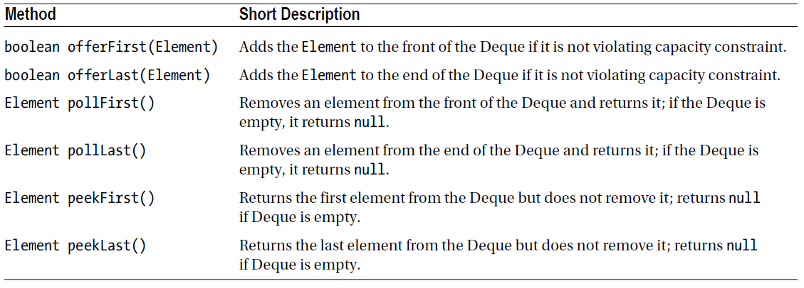

Table. Commonly Used Methods in the Deque Interface

Comparable and Comparator Interfaces

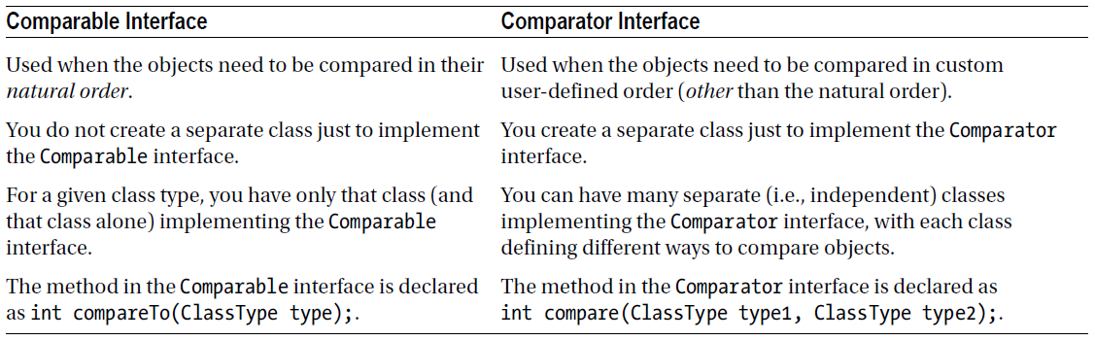

Algorithms (Collections Class)

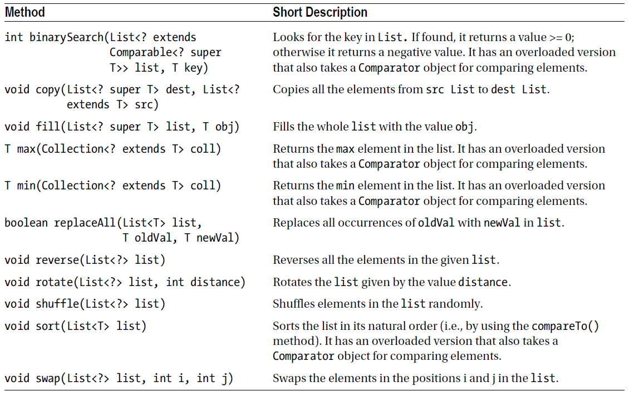

Table. Important Algorithms (Static Methods in the Collections Class)

Methods in the Arrays Class

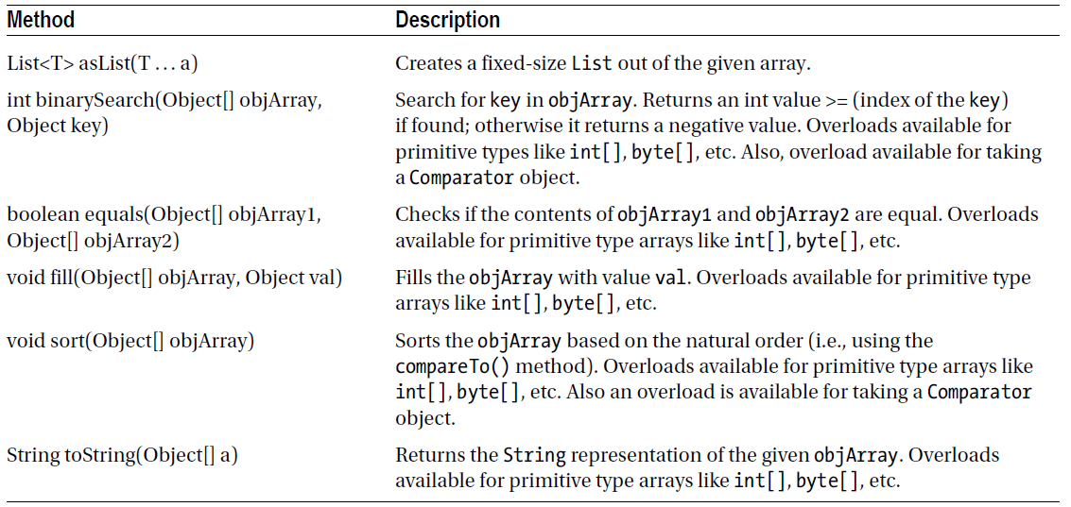

Table. Important (Static) Methods in the Arrays Class

Questions

1. Predict the output of this program:
import java.util.*;
class UtilitiesTest {
public static void main(String []args) {
List<int> intList = new ArrayList<>();
intList.add(10);
intList.add(20);
System.out.println("The list is: " + intList);
}
}
A. I t prints the following: The list is: [10, 20].
B. I t prints the following: The list is: [20, 10].
C. I t results in a compiler error.
D. I t results in a runtime exception.

2. Predict the output of this program:
import java.util.*;
class UtilitiesTest {
public static void main(String []args) {
List<Integer> intList = new LinkedList<>();
List<Double> dblList = new LinkedList<>();
System.out.println("First type: " + intList.getClass());
System.out.println("Second type:" + dblList.getClass());
}
}
A. I t prints the following:
First type: class java.util.LinkedList
Second type:class java.util.LinkedList
B. I t prints the following:
First type: class java.util.LinkedList<Integer>
Second type:class java.util.LinkedList<Double>
C. I t results in a compiler error.
D. I t results in a runtime exception.

3. Which statement is true with respect to List<?> and List<Object>?
A. Both are same, just two different ways to express a same thing.
B. List<?> is a homogenous list of elements of a same unknown type and
List<Object> is a heterogeneous list of elements of different types.
C. List<?> is a heterogeneous list of elements of different types and List<Object> is a homogenous list of elements of a same unknown type.

4. Predict the output of this program:
import java.io.*;
class LastError<T> {
private T lastError;
void setError(T t){
lastError = t;
System.out.println("LastError: setError");
}
}
class StrLastError<S extends CharSequence> extends LastError<String>{
public StrLastError(S s) {
}
void setError(S s){
System.out.println("StrLastError: setError");
}
}
class Test {
public static void main(String []args) {
StrLastError<String> err = new StrLastError<String>("Error");
err.setError("Last error");
}
}

A. I t prints the following: StrLastError: setError.
B. I t prints the following: LastError: setError.
C. I t results in a compilation error.
D. I t results in a runtime exception.

